2015.09.07 기준
 | VACUUM GAUGE PRICE LIST

*부가세별도
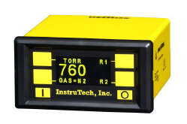  VGC301A | VGC301A Convection Vacuum Gauge Controller
 | 대리점 | 장비업체(딜러) | 소비자 | 비고
 | 850,000 | 850,000 | 1,000,000 | Flange NW25  Power Supply Included

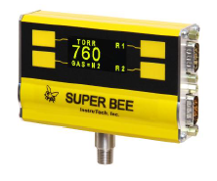  CVM201 | CVM201 Convection Vacuum Gauge Module
 | 대리점 | 장비업체(딜러) | 소비자 | 비고
 | 620,000 | 650,000 | 750,000 | Flange NW25  Power Supply Included

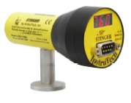  CVM211 | CVM211 Convection Vacuum Gauge Module
 | 대리점 | 장비업체(딜러) | 소비자 | 비고
 | 400,000 | 450,000 | 500,000 | Flange NW25  Power Supply Included

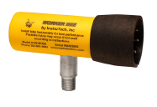  CVG101 | CVG101 Convection Vacuum Gauge Sensor
 | 대리점 | 장비업체(딜러) | 소비자 | 비고
 | 190,000 | 230,000 | 280,000 | Flange NW25

B-RAX3000 series Vacuum Gauge Controller
*부가세별도
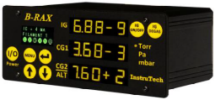  B-RAX Series |  | B-RAX Ionization and Convection Vacuum Gauge Module
 |  | 규격 |  | 대리점 |  | 장비업체(딜러) |  | 소비자 |  | 비고
 |  | 3200 |  |  |  | 1,500,000 |  | 1,500,000 |  | Power Supply 포함  CG/Ion Gauge Cable 미포함
 |  | 3300 |  |  |  | 2,500,000 |  | 2,500,000 |  | Power Supply 포함  CG/Ion Gauge Cable 미포함
 |  | 3400 |  |  |  | 2,600,000 |  | 2,600,000 |  | Power Supply 포함  CG/Ion Gauge Cable 미포함
Series 600 Hot Cathode Ionization Vacuum Gauge For B-RAX 3300/3400
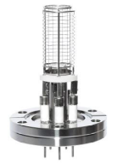  BA601 |  |  | 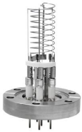  BA602 |  |  |  | 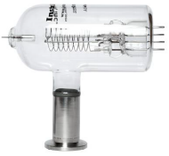  BA603
딜러 | 560,000 |  | 딜러 |  | 560,000 |  | 딜러 |  | 280,000
소비자 | 600,000 |  | 소비자 |  | 600,000 |  | 소비자 |  | 300,000

Ionization Vacuum Gauge For B-RAX 3200
Hot Cathode |  | Cold Cathode
IGM400  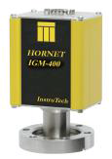 |  | CCM500  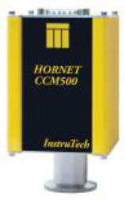
딜러 | 1,000,000 | 딜러 | 1,500,000
소비자 | 1,000,000 | 소비자 | 1,600,000
Replacement Sensor IG4 series |  | Replacement Sensor CCM5 series
딜러 | 400,000 | 딜러 | 750,000
소비자 | 450,000 | 소비자 | 800,000

*부가세별도
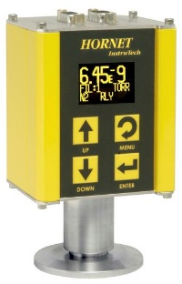IGM401 | IGM401 Hot Cathode Miniature-Ionization Vacuum Gauge
 | 대리점 | 장비업체(딜러) | 소비자 | 비고
 |  | 1,250,000 | 1,300,000 | Power Supply  포함
Replacement Sensor  IG4 series |  | 400,000 | 450,000 | 교정비용포함  Flange NW25

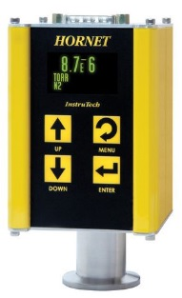CCM501 | CCM501 Cold Cathode Miniature-Ionization Vacuum Gauge
 | 대리점 | 장비업체(딜러) | 소비자 | 비고
 |  | 1,600,000 | 1,700,000 | Power Supply  포함
Replacement Sensor  CC5 series |  | 750,000 | 800,000 | 교정비용포함  Flange NW25

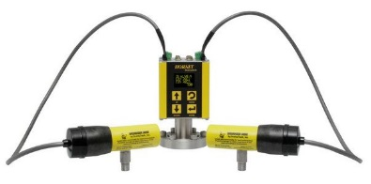IGM402 | IGM402 Hot Cathode Miniature-Ionization Vacuum Gauge with Dual Convection
 | 대리점 | 장비업체(딜러) | 소비자 | 비고
 |  | 1,400,000 | 1,500,000 | Convection Gauge Cable  미포함
Replacement Sensor  IG4 series |  | 400,000 | 450,000 | 교정비용포함  Flange NW25

FlexRax® 4000 Multi-Gauge Controller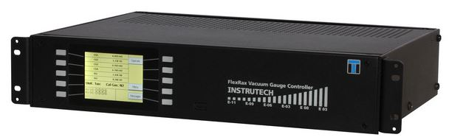
Option cards selection | FLX4000 -  (Base Price: $1,045) | # - # - # - # - # - # - #  $ Price x 1.3 x 환율
#Slot 1  IGM/CG* option (operates 2 convection and 1 IGM 400 / CCM500 ion Gauge  AI/O-R* option (4 setpoint relays, 4 analog outputs, 1 analog input)  AI/O-R* option (8 setpoint relays, 4 analog outputs, 1 analog input)  None | IC ($280)  AI4 ($280)  AI8 ($345)  X ($0)
#Slot 2  IGM/CG* Option (operates 2 convection and 1 IGM 400 / CCM500 ion Gauge  AI/O-R* option (4 setpoint relays, 4 analog outputs, 1 analog input)  AI/O-R* option (8 setpoint relays, 4 analog outputs, 1 analog input)  None | IC ($280)  AI4 ($280)  AI8 ($345)  X ($0)
#Slot 3  AI/O-R* option (4 setpoint relays, 4 analog outputs, 1 analog input)  AI/O-R* option (8 setpoint relays, 4 analog outputs, 1 analog input)  None | AI4 ($280)  AI8 ($345)  X ($0)
#Slot 4  AI/O-R* option (4 setpoint relays, 4 analog outputs, 1 analog input)  AI/O-R* option (8 setpoint relays, 4 analog outputs, 1 analog input)  None | AI4 ($280)  AI8 ($345)  X ($0)
#Slot 5  IGR option (operates one I²R degas B-A Glass or Nude Ionization gauge  IGE option (operates one EB Degas B-A Ionization gauge)  None | IR ($540)  IE ($565)  X ($0)
#Slot 6  IGR option (operates one I²R degas B-A Glass or Nude Ionization gauge  IGE option (operates one EB Degas B-A Ionization gauge)  None | IR ($540)  IE ($565)  X ($0)
#Slot 7  Serial communication option – RS485/RS232  None | CM ($175)  X ($0)

See the next page for gauge cable assemblies.
All gauge to be connected to the FlexRax 4000 must be ordered separately.
Cable Assemblies for Gauge
BA601 / BA602 Nude IG Cable – 50 Deg C max Temperature
Cable lengths | BA601/BA602 Nude IG  Cable P/N | Dealer. | Customer.
10 ft. (3m) | IRN441-1-10F | 350,000 | 350,000
25 ft. (8m) | IRN441-1-25F | 400,000 | 400,000
50 ft. (15m) | IRN441-1-50F | 500,000 | 500,000
>50 ft. | Consult factory
BA601 / BA602 Nude IG Cable: Bakeable to 200 Deg C, provided with push-on sockets for connection to transducer pins.
Cable lengths | BA601/BA602 Nude IG  Cable P/N | Dealer. | Customer.
10 ft. (3m) | IRNBD441-1-10F | 380,000 | 380,000
25 ft. (8m) | IRNBD441-1-25F | 550,000 | 550,000
50 ft. (15m) | IRNBD441-1-50F | 750,000 | 750,000
>50 ft. | Consult factory
BA603 Glass IG Cable – 50 Deg C max Temperature
Cable lengths | BA603 Glass IG  Cable P/N | Dealer. | Customer.
10 ft. (3m) | IRG441-1-10F | 250,000 | 250,000
25 ft. (8m) | IRG441-1-25F | 350,000 | 350,000
50 ft. (15m) | IRG441-1-50F | 450,000 | 450,000
>50 ft. | Consult factory
IGM400 and CCM500 ionization Gauge Cable
Cable lengths | IGM400/CCM500  Cable P/N | Dealer. | Customer.
10 ft. (3m) | BXC400-1-10F | 120,000 | 120,000
25 ft. (8m) | BXC400-1-25F | 150,000 | 150,000
50 ft. (15m) | BXC400-1-50F | 200,000 | 200,000
CVG101 Convection Gauge Cable
Cable lengths | BA601/BA602 Nude IG  Cable P/N | Dealer. | Customer.
10 ft. (3m) | CB421-1-10F | 120,000 | 120,000
25 ft. (8m) | CB421-1-25F | 150,000 | 150,000
50 ft. (15m) | CB421-1-50F | 200,000 | 200,000

